



**GOKARAJU RANGARAJU INSTITUTE OF ENGINEERING AND TECHNOLOGY**

**AUTONOMOUS**

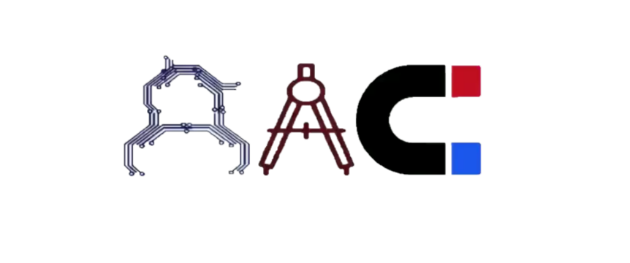

This is to certify that the project titled

“**SMART PASS BOX CONTROLLER**’’

is a bonafide work carried out by the following students in partial fulfilment of the requirements for Advanced Academic Center intern, submitted to the chair, AAC during the academic year 2019-20.

|  |  |  |
| --- | --- | --- |
| **NAME** | **ROLL NO.** | **BRANCH** |
| G.KRISHNA MITHRA | 18241A04L2 | ECE |
| N.NIKHIL | 18241A04M0 | ECE |
| P.SAI TEJA | 18241A04M2 | ECE |
| P.BHARGAV | 18241A04M4 | ECE |
| P.ROHIT SAI | 18241A04M6 | ECE |

Dr/Ms./Mr.

Dr B R K Reddy Dr Ramamurthy Suri

Project Supervisor Program Coordinator Associate Dean, AAC



We express our deep sense of gratitude to our respected Director, Gokaraju Rangaraju Institute of Engineering and Technology for the valuable guidance and for permitting us to carry out this project.

With immense pleasure, we record our deep sense of gratitude to our respected principal, for permitting us to carry out this project.

We are thankful to Associate Dean, Advance Academic Centre for providing us appropriate ecosystem required for the project to complete.

We are thankful to our project supervisor who spared valuable time for us and influence novel ideas to guide us. I am indebted to all the above without whom I would not have concluded the project.

**CONTENTS**

1. **ABSTRACT** 6
2. **EMBEDDED SYSTEMS**

Introduction 7

Applications 8

1. **ARDUINO MEGA**

Introduction 9

Technical Specifications 10

Arduino MEGA Pins 10

Advantages of Arduino Board 11

Different types of Arduino Boards 11

Features of Arduino Boards 12

Applications 12

1. **ULTRASONIC SENSOR**

Introduction 13

Working 13

Uses of Ultrasonic Sensor 14

1. **ULTRAVIOLET LIGHT**

Introduction 15

Discovery 16

Applications 17

1. **ELECTROMAGNET**

Introduction 18

History 19

Uses of Electromagnet 20

1. **RELAY**

Introduction 21

History 22

Working Principle 22

Construction 23

1. **SMART PASS BOX CONTROLLER**

Introduction 26

Types of Pass Boxes 26

Uniqueness of the Innovation 27

Construction 28

Working 29

Block Diagram 30

Concept and Objectives 30

Project code 31

Applications 34

**ABSTRACT**

Sterilization process refers to the elimination/removal of all form of biological agents present in a specified region. Sterilization can be achieved through various means such as heating, irradiation, high pressure and filtration. It has been one of the prominent process in any production. In previous times it has been very difficult to achieve sterilization mainly in the pharmaceutical area and the other industrial area, though the demand for this process never descended. Due to the development of the technology pass box is one of the solutions for the Sterilization. This process had extended its roots to all the areas of the human life for example, in the medical industries there is a need to transfer the material form one room to another room without any change in the atmospheric conditions. If there is any change in the material’s physical or chemical properties it affects the product. In such cases the Pass Box will be very helpful for the transfer of the materials. The pass box is used between the classified and the unclassified areas. It works on the principle of interlocking door mechanism with UV present inside the box. It accepts the material from one side and undergoes a process called “Sterilization” in the presence of UV light. After the completion of the process the pure material can be collected from the other side of the box.

**CHAPTER 1**

**EMBEDDED SYSTEMS**

INTRODUCTION:

An embedded system is a controller with a dedicated function within a larger mechanical or electrical system, often with [real-time computing](https://en.wikipedia.org/wiki/Real-time_computing) constraints.  It is embedded as part of a complete device often including hardware and mechanical parts. Embedded systems control many devices in common use today. Ninety-eight percent of all [microprocessors](https://en.wikipedia.org/wiki/Microprocessor) manufactured are used in embedded systems.

Modern embedded systems are often based on [microcontrollers](https://en.wikipedia.org/wiki/Microcontroller) . Since the embedded system is dedicated to specific tasks, design engineers can optimize it to reduce the size and cost of the product and increase the reliability and performance. Some embedded systems are mass-produced, benefiting from  [economies of scale](https://en.wikipedia.org/wiki/Economies_of_scale).

Embedded systems range from portable devices such as [digital watches](https://en.wikipedia.org/wiki/Digital_watch) and  [MP3 players](https://en.wikipedia.org/wiki/MP3_player), to large stationary installations like [traffic lights](https://en.wikipedia.org/wiki/Traffic_light), [programmable logic controllers](https://en.wikipedia.org/wiki/Programmable_logic_controller), and largely complex systems like [hybrid vehicles](https://en.wikipedia.org/wiki/Hybrid_vehicles), [MRI](https://en.wikipedia.org/wiki/MRI), and  [avionics](https://en.wikipedia.org/wiki/Avionics). Complexity varies from low, with a single [microcontroller](https://en.wikipedia.org/wiki/Microcontroller) chip, to very high with multiple units, [peripherals](https://en.wikipedia.org/wiki/Peripheral) and networks mounted inside a large  [chassis](https://en.wikipedia.org/wiki/Chassis) or enclosure.

Embedded systems have become very important today as they control many of the common devices we use. An embedded system is some combination of computer hardware and software, either fixed in capability or programmable, that is specifically designed for a particular kind of application device. Industrial machines, automobiles, medical equipment, cameras, household appliances, airplanes, vending machines, and toys.

APPLICATIONS:

Embedded systems are commonly found in consumer, industrial, automotive, medical, commercial and military applications. Telecommunications systems employ numerous embedded systems from [telephone switches](https://en.wikipedia.org/wiki/Telephone_switch) for the network to  [cell phones](https://en.wikipedia.org/wiki/Mobile_phone) at the end user. Computer networking uses dedicated [routers](https://en.wikipedia.org/wiki/Router_(computing)) and  [network bridges](https://en.wikipedia.org/wiki/Network_bridge) to route data.

Household appliances such as [microwave ovens](https://en.wikipedia.org/wiki/Microwave_oven), [washing machines](https://en.wikipedia.org/wiki/Washing_machine) include embedded systems to provide flexibility, efficiency and features. Advanced [HVAC](https://en.wikipedia.org/wiki/HVAC) systems use networked [thermostats](https://en.wikipedia.org/wiki/Thermostat) to more accurately and efficiently control temperature that can change by time of day and [season](https://en.wikipedia.org/wiki/Season). [Home automation](https://en.wikipedia.org/wiki/Home_automation) uses wired- and wireless-networking that can be used to control lights, climate, security, audio/visual, surveillance, etc., all of which use embedded devices for sensing and controlling.

Transportation systems from flight to automobiles increasingly use embedded systems. [Automobiles](https://en.wikipedia.org/wiki/Automobile), [electric vehicles](https://en.wikipedia.org/wiki/Electric_vehicle), and [hybrid vehicles](https://en.wikipedia.org/wiki/Hybrid_vehicle) increasingly use embedded systems to maximize efficiency and reduce pollution. [Medical equipment](https://en.wikipedia.org/wiki/Medical_equipment) uses embedded systems for [vital signs](https://en.wikipedia.org/wiki/Vital_signs) monitoring, [electronic stethoscopes](https://en.wikipedia.org/wiki/Electronic_stethoscope) for amplifying sounds, and various [medical imaging](https://en.wikipedia.org/wiki/Medical_imaging)  for non-invasive internal inspections. Embedded systems within medical equipment are often powered by industrial computers.

Embedded systems are used in transportation, fire safety, safety and security, medical applications and life critical systems, as these systems can be isolated from hacking. In dealing with security, the embedded systems can be self-sufficient and be able to deal with cut electrical and communication systems.

**CHAPTER 2**

**ARDUINO MEGA**

INTRODUCTION:

Arduino Mega 2560 is a [Microcontroller](https://www.theengineeringprojects.com/2018/03/introduction-to-microcontrollers.html) board based on Atmega2560. It comes with more memory space and I/O pins as compared to other boards available in the market. There are 54 digital I/O pins and 16 analog pins incorporated on the board that make this device unique and stand out from others. Out of 54 digital I/O, 15 are used for PWM (pulse width modulation). A crystal oscillator of 16MHz frequency is added on the board. This board comes with USB cable port that is used to connect and transfer code from computer to the board. DC power jack is coupled with the board that is used to power the board. ICSP header is a remarkable addition to Arduino Mega which is used for programming the Arduino and uploading the code from the computer. This board comes with two voltage regulator i.e. 5V and 3.3V which provides the flexibility to regulate the voltage as per requirements. There is no much difference between Arduino Uno and Arduino Mega except later comes with more memory space, bigger size and more I/O pins. Arduino software called Arduino IDE is used to program the board which is a common software used for all boards belonged to Arduino family. Availability of Atmega16 on the board makes it different than Arduino Pro Mini which uses USB to serial converter to program the board. There is a reset button and 4 hardware serial port called USART which produces a maximum speed for setting up communication.

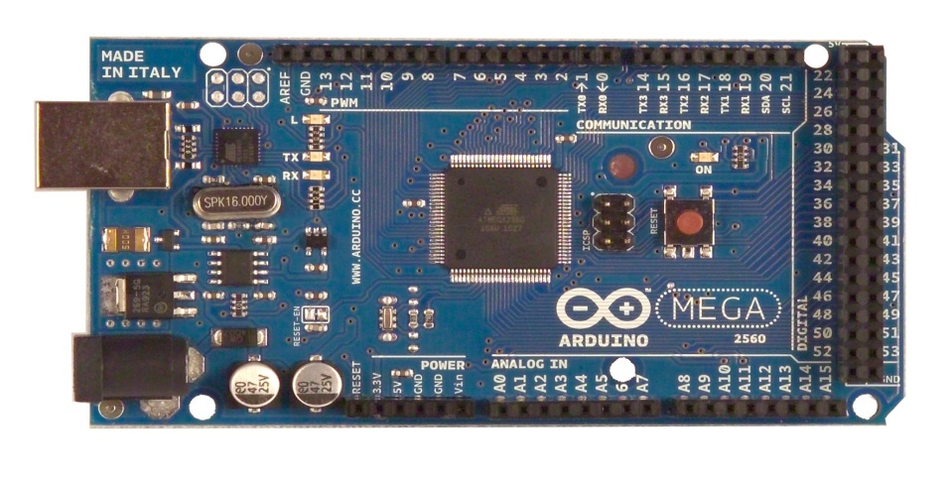

TECHNICAL SPECIFICATIONS:

Microcontroller: ATmega2560

Operating Voltage: 5V

Input Voltage (recommended): 7-12V

Input Voltage (limits): 6-20V

Digital I/O Pins: 54 (of which 14 provide PWM output)

Analog Input Pins: 16

DC Current per I/O Pin: 40 mA

DC Current for 3.3V Pin: 50 mA

Flash Memory: 256 KB of which 8 KB used by bootloader

SRAM: 8 KB

EEPROM: 4 KB

Clock Speed: 16 MHz

ARDUINO MEGA PINS:

**VIN**: The input voltage to the Arduino board when it's using an external power source. We can supply voltage through this pin, or, if supplying voltage via the power jack, access it through this pin.

**5V:** The regulated power supply used to power the microcontroller and other components on the board. This can come either from VIN via an on-board regulator, or be supplied by USB or another regulated 5V supply.

**3V3:** A 3.3 volt supply generated by the on-board regulator. Maximum current draw is 50 mA.

**GND:** Ground pins.

**LED 13**: There is a built-in LED connected to digital pin 13. When the pin is HIGH value, the LED is on, when the pin is LOW, it's off.

**AREF:**  Reference voltage for the analog inputs. Used with analogReference().

**Reset:** Bring this line LOW to reset the microcontroller. Typically used to add a reset button to shields which block the one on the

ADVANTAGES OF ARDUINO BOARD:

Arduino also makes simpler the working process of microcontroller, but it gives some advantages over other systems like:

They are inexpensive

They provide cross-platform

Simple, clear programming environment

Open source and extensible software

Open source and extensible hardware

DIFFERENT TYPES OF ARDUINO BOARDS:

The list of Arduino boards includes the following such as:

Arduino Uno (R3)

LilyPad Arduino

Red Board

Arduino Mega (R3)

Arduino Leonardo

FEATURES OF ARDUINO BOARD:

|  |  |  |  |  |
| --- | --- | --- | --- | --- |
| Arduino Board | Processor | Memory | Digital I/O | Analogue I/O |
| Arduino Uno | 16Mhz ATmega328 | 2KB SRAM, 32KB flash | 14 | 6 input, 0 output |
| Arduino Due | 84MHz AT91SAM3X8E | 96KB SRAM, 512KB flash | 54 | 12 input, 2 output |
| Arduino Mega | 16MHz ATmega2560 | 8KB SRAM, 256KB flash | 54 | 16 input, 0 output |
| Arduino Leonardo | 16MHz ATmega32u4 | 2.5KB SRAM, 32KB flash | 20 | 12 input, 0 output |

APPLICATIONS:

Robotics and Control system

Agricultural Areas

Home Automation

Traffic Lights Control System

Water Level Indication

Security and Defense System

Parking Lot Counter

Medical, Industrial Automation

**CHAPTER 3**

**ULTRASONIC SENSOR**

INTRODUCTION:

Ultrasonic sensing is one of the best ways to sense proximity and detect levels with high reliability. An ultrasonic sensor is an instrument that measures the distance to an object using ultrasonic sound waves. An ultrasonic sensor uses a transducer to send and receive ultrasonic pulses that relay back information about an object’s proximity. High-frequency sound waves reflect from boundaries to produce distinct echo patterns.

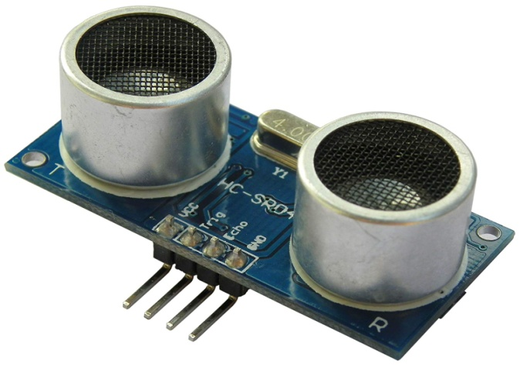

WORKING:

Ultrasonic sound vibrates at a frequency above the range of human hearing. Transducers are the microphones used to receive and send the ultrasonic sound. Our [ultrasonic sensors](https://www.maxbotix.com/SelectionGuide/Selection-Guide.htm), like many others, use a single transducer to send a pulse and to receive the echo.  The sensor determines the distance to a target by measuring time lapses between the sending and receiving of the ultrasonic pulse.

[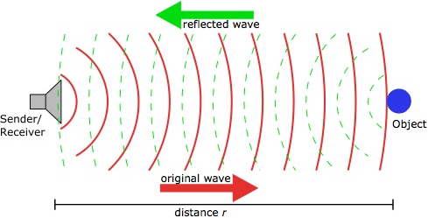](https://www.google.co.in/url?sa=i&source=images&cd=&ved=2ahUKEwixrM-v5rrjAhUVbo8KHelEDLcQjRx6BAgBEAU&url=https://www.researchgate.net/figure/The-Ultrasonic-sensor-function_fig4_299511206&psig=AOvVaw3vxWC5iAnhkNs8Zcx-lsQK&ust=1563413247615249)

USES OF ULTRASONIC SENSOR:

Ultrasound is reliable in any lighting environment and can be used inside or outside.  Ultrasonic sensors can handle collision avoidance for a robot, and being moved often, as long as it isn’t too fast. Ultrasonic sensors are so widely used that they can be reliably implemented in grain bin sensing applications, water level sensing, drone applications and sensing cars at your local drive-thru restaurant or bank. Ultrasonic rangefinders are commonly used as devices to detect a collision.

Ultrasonic Sensors are best used in the non-contact detection of:

Presence

Level

Position

Distance

Ultrasonic sensors are Independent of:

Light

Smoke

Dust

Color

Material

**CHAPTER 4**

**ULTRAVIOLET LIGHT**

INTRODUCTION:

Ultraviolet (UV) designates a band of the electromagnetic spectrum with wavelength from 10 nm to 400 nm, shorter than that of [visible light](https://en.wikipedia.org/wiki/Visible_light) but longer than [X-rays](https://en.wikipedia.org/wiki/X-rays). UV radiation is present in [sunlight](https://en.wikipedia.org/wiki/Sunlight), and contributes about 10% of the total output of the Sun. It is also produced by [electric arcs](https://en.wikipedia.org/wiki/Electric_arc) and specialized lights, such as [mercury-vapor lamps](https://en.wikipedia.org/wiki/Mercury-vapor_lamp), [tanning lamps](https://en.wikipedia.org/wiki/Tanning_lamp), and [black lights](https://en.wikipedia.org/wiki/Black_light).

[Suntan](https://en.wikipedia.org/wiki/Sun_tanning) and [sunburn](https://en.wikipedia.org/wiki/Sunburn) are familiar effects of over-exposure of the skin to UV, along with higher risk of [skin cancer](https://en.wikipedia.org/wiki/Skin_cancer). Living things on dry land would be severely damaged by ultraviolet radiation from the Sun if most of it were not filtered out by the Earth's atmosphere. More energetic, shorter-wavelength "extreme" UV below 121 nm ionizes air so strongly that it is absorbed before it reaches the ground.

Ultraviolet is also responsible for the formation of bone-strengthening  [vitamin D](https://en.wikipedia.org/wiki/Vitamin_D) in most land vertebrates, including humans. The UV spectrum thus has effects both beneficial and harmful to human health.

The lower wavelength limit of human vision is conventionally taken as 400 nm, so ultraviolet rays are invisible to humans, although some people can perceive light at slightly shorter wavelengths than this. Insects, birds, and some mammals can see near-UV light.

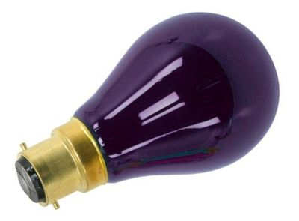 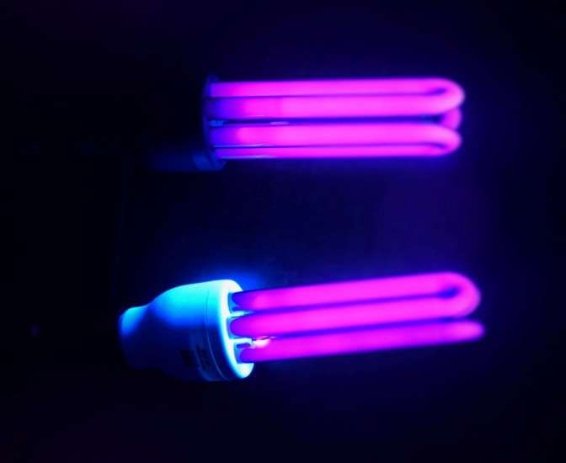

DISCOVERY:

"Ultraviolet" means "beyond violet”, violet being the color of the highest frequencies of visible light. Ultraviolet has a higher frequency than violet light. UV radiation was discovered in 1801 when the German physicist [Johann Wilhelm Ritter](https://en.wikipedia.org/wiki/Johann_Wilhelm_Ritter) observed that invisible rays just beyond the violet end of the visible spectrum darkened [silver chloride](https://en.wikipedia.org/wiki/Silver_chloride)-soaked paper more quickly than violet light itself. He called them "oxidizing rays" to emphasize [chemical reactivity](https://en.wikipedia.org/wiki/Reactivity_(chemistry)) and to distinguish them from "heat rays", [discovered the previous year](https://en.wikipedia.org/wiki/Infrared#History_of_infrared_science) at the other end of the visible spectrum. The simpler term "chemical rays" was adopted soon afterwards, and remained popular throughout the 19th century, although some said that this radiation was entirely different from light.

The terms "chemical rays" and "heat rays" were eventually dropped in favor of ultraviolet and [infrared](https://en.wikipedia.org/wiki/Infrared) [radiation](https://en.wikipedia.org/wiki/Radiation), respectively.  In 1878 the sterilizing effect of short-wavelength light by killing bacteria was discovered. By 1903 it was known the most effective wavelengths were around 250 nm. In 1960, the effect of ultraviolet radiation on DNA was established.

The discovery of the ultraviolet radiation with wavelengths below 200 nm, named "vacuum ultraviolet" because it is strongly absorbed by the oxygen in air, was made in 1893 by the German physicist [Victor Schumann](https://en.wikipedia.org/wiki/Victor_Schumann).

APPLICATIONS:

The following information gives some uses of specific wavelength bands in the UV spectrum

13.5 nm: [Extreme ultraviolet lithography](https://en.wikipedia.org/wiki/Extreme_ultraviolet_lithography)

30–200 nm: [Photo ionization](https://en.wikipedia.org/wiki/Photoionization), [ultraviolet photoelectron spectroscopy](https://en.wikipedia.org/wiki/Ultraviolet_photoelectron_spectroscopy), standard [integrated circuit](https://en.wikipedia.org/wiki/Integrated_circuit) manufacture by [photolithography](https://en.wikipedia.org/wiki/Photolithography)

230–365 nm: UV-ID, label tracking, [barcodes](https://en.wikipedia.org/wiki/Barcode)

230–400 nm: Optical [sensors](https://en.wikipedia.org/wiki/Sensor), various instrumentation

240–280 nm: [Disinfection](https://en.wikipedia.org/wiki/Disinfection), decontamination of surfaces and water ([DNA](https://en.wikipedia.org/wiki/DNA) absorption has a peak at 260 nm)

200–400 nm: [Forensic analysis](https://en.wikipedia.org/wiki/Forensic_analysis), drug detection

270–360 nm: [Protein](https://en.wikipedia.org/wiki/Protein) analysis, [DNA sequencing](https://en.wikipedia.org/wiki/DNA_sequencing), [drug discovery](https://en.wikipedia.org/wiki/Drug_discovery)

280–400 nm: [Medical imaging](https://en.wikipedia.org/wiki/Medical_imaging) of [cells](https://en.wikipedia.org/wiki/Cell_(biology))

300–320 nm: [Light therapy](https://en.wikipedia.org/wiki/Light_therapy) in medicine

300–365 nm: [Curing](https://en.wikipedia.org/wiki/Curing_(chemistry)) of [polymers](https://en.wikipedia.org/wiki/Polymer) and [printer inks](https://en.wikipedia.org/wiki/Printer_ink)

350–370 nm: [Bug zappers](https://en.wikipedia.org/wiki/Bug_zapper) (flies are most attracted to light at 365 nm)

**CHAPTER 5**

**ELECTROMAGNET**

INTRODUCTION:

An electromagnet is a type of [magnet](https://en.wikipedia.org/wiki/Magnet) in which the [magnetic field](https://en.wikipedia.org/wiki/Magnetic_field) is produced by an [electric current](https://en.wikipedia.org/wiki/Electric_current). Electromagnets usually consist of wire wound into a [coil](https://en.wikipedia.org/wiki/Electromagnetic_coil). A current through the wire creates a magnetic field which is concentrated in the hole, denoting the center of the coil. The magnetic field disappears when the current is turned off. The wire turns are often wound around a [magnetic core](https://en.wikipedia.org/wiki/Magnetic_core) made from a [ferro- magnetic](https://en.wikipedia.org/wiki/Ferromagnetic) or [ferri-magnetic](https://en.wikipedia.org/wiki/Ferrimagnetic) material such as [iron](https://en.wikipedia.org/wiki/Iron); the magnetic core concentrates the [magnetic flux](https://en.wikipedia.org/wiki/Magnetic_flux) and makes a more powerful magnet.

The main advantage of an electromagnet over a [permanent magnet](https://en.wikipedia.org/wiki/Permanent_magnet) is that the magnetic field can be quickly changed by controlling the amount of electric current in the winding. However, unlike a permanent magnet that needs no power, an electromagnet requires a continuous supply of current to maintain the magnetic field.

Electromagnets are widely used as components of other electrical devices, such as [motors](https://en.wikipedia.org/wiki/Electric_motor), [generators](https://en.wikipedia.org/wiki/Electric_generator), [electromechanical solenoids](https://en.wikipedia.org/wiki/Solenoid#Applications), [relays](https://en.wikipedia.org/wiki/Relay), [loudspeakers](https://en.wikipedia.org/wiki/Loudspeaker),  [hard disks](https://en.wikipedia.org/wiki/Hard_disk), [MRI machines](https://en.wikipedia.org/wiki/Magnetic_resonance_imaging), scientific instruments, and [magnetic separation](https://en.wikipedia.org/wiki/Magnetic_separation)  equipment. Electromagnets are also employed in industry for picking up and moving heavy iron objects such as scrap iron and steel.

HISTORY:

Danish scientist [Hans Christian Orsted](https://en.wikipedia.org/wiki/Hans_Christian_%C3%98rsted) discovered in 1820 that electric currents create magnetic fields. British scientist [William Sturgeon](https://en.wikipedia.org/wiki/William_Sturgeon) invented the electromagnet in 1824. His first electromagnet was a horseshoe-shaped piece of iron that was wrapped with about 18 turns of bare copper wire. The iron was [varnished](https://en.wikipedia.org/wiki/Varnish) to insulate it from the windings. When a current was passed through the coil, the iron became magnetized and attracted other pieces of iron; when the current was stopped, it lost magnetization. Sturgeon displayed its power by showing that although it only weighed around 200 grams, it could lift around 4 kilograms when the current of a single-cell battery was applied. However, Sturgeon's magnets were weak because the uninsulated wire he used could only be wrapped in a single spaced out layer around the core, limiting the number of turns.

Beginning in 1830, US scientist [Joseph Henry](https://en.wikipedia.org/wiki/Joseph_Henry) systematically improved and popularized the electromagnet. By using wire insulated by silk thread, and inspired by [Schweigger](https://en.wikipedia.org/wiki/Johann_Schweigger)'s use of multiple turns of wire to make a [galvanometer](https://en.wikipedia.org/wiki/Galvanometer),  he was able to wind multiple layers of wire on cores, creating powerful magnets with thousands of turns of wire, including one that could support 936 kg. The first major use for electromagnets was in [telegraph sounders](https://en.wikipedia.org/wiki/Telegraph_sounder).

The [magnetic domain](https://en.wikipedia.org/wiki/Magnetic_domain) theory of how ferromagnetic cores work was first proposed in 1906 by French physicist [Pierre-Ernest Weiss](https://en.wikipedia.org/wiki/Pierre-Ernest_Weiss), and the detailed modern quantum mechanical theory of ferromagnetism was worked out in the 1920s by [Werner Heisenberg](https://en.wikipedia.org/wiki/Werner_Heisenberg), [Lev Landau](https://en.wikipedia.org/wiki/Lev_Landau), [Felix Bloch](https://en.wikipedia.org/wiki/Felix_Bloch) and others.

USES OF ELECTROMAGNETS:

Electromagnets are very widely used in electric and [electromechanical](https://en.wikipedia.org/wiki/Electromechanical) devices, including:

[Motors](https://en.wikipedia.org/wiki/Electric_motor) and [generators](https://en.wikipedia.org/wiki/Electric_generator)

[Transformers](https://en.wikipedia.org/wiki/Transformer)

[Relays](https://en.wikipedia.org/wiki/Relay)

[Electric bells](https://en.wikipedia.org/wiki/Electric_bell) and buzzers

[Loudspeakers](https://en.wikipedia.org/wiki/Loudspeaker) and [headphones](https://en.wikipedia.org/wiki/Headphone)

[Actuators](https://en.wikipedia.org/wiki/Actuator) such as valves

[Magnetic recording](https://en.wikipedia.org/wiki/Magnetic_recording) and data storage equipment

[MRI](https://en.wikipedia.org/wiki/MRI) machines

Scientific equipment such as [mass spectrometers](https://en.wikipedia.org/wiki/Mass_spectrometer)

[Particle accelerators](https://en.wikipedia.org/wiki/Particle_accelerator)

[Magnetic locks](https://en.wikipedia.org/wiki/Magnetic_lock)

Industrial lifting magnets

[Magnetic levitation](https://en.wikipedia.org/wiki/Magnetic_levitation)

[Induction heating](https://en.wikipedia.org/wiki/Induction_heating) for cooking, manufacturing, and [hyperthermia therapy](https://en.wikipedia.org/wiki/Hyperthermia_therapy)

**CHAPTER 6**

**RELAY**

INTRODUCTION:

A relay is an [electrically](https://en.wikipedia.org/wiki/Electric) operated [switch](https://en.wikipedia.org/wiki/Switch). Many relays use an [electromagnet](https://en.wikipedia.org/wiki/Electromagnet) to mechanically operate a switch, but other operating principles are also used, such as [solid-state relays](https://en.wikipedia.org/wiki/Solid-state_relay). Relays are used where it is necessary to control a circuit by a separate low-power signal, or where several circuits must be controlled by one signal. The first relays were used in long distance [telegraph](https://en.wikipedia.org/wiki/Electrical_telegraph) circuits as amplifiers. Relays were used extensively in telephone exchanges and early computers to perform logical operations.

A type of relay that can handle the high power required to directly control an electric motor or other loads is called a [contactor](https://en.wikipedia.org/wiki/Contactor" \o "Contactor). [Solid-state relays](https://en.wikipedia.org/wiki/Solid-state_relay)  control power circuits with no [moving parts](https://en.wikipedia.org/wiki/Moving_parts), instead using a semiconductor device to perform switching. Relays with calibrated operating characteristics and sometimes multiple operating coils are used to protect electrical circuits from overload or faults; in modern electric power systems these functions are performed by digital instruments still called "[protective relays](https://en.wikipedia.org/wiki/Protective_relay)". Magnetic latching relays require one pulse of coil power to move their contacts in one direction, and another, redirected pulse to move them back. Repeated pulses from the same input have no effect. Magnetic latching relays are useful in applications where interrupted power should not affect the circuits that the relay is controlling.

HISTORY:

In 1809 [Samuel Thomas von Sömmerring](https://en.wikipedia.org/wiki/Samuel_Thomas_von_S%C3%B6mmerring) designed an electrolytic relay as part of his electrochemical telegraph. American scientist [Joseph Henry](https://en.wikipedia.org/wiki/Joseph_Henry) is often claimed to have invented a relay in 1835 in order to improve his version of the [electrical telegraph](https://en.wikipedia.org/wiki/Electrical_telegraph), developed earlier in 1831. It is claimed that English inventor [Edward Davy](https://en.wikipedia.org/wiki/Edward_Davy) "certainly invented the electric relay". in his [electric telegraph](https://en.wikipedia.org/wiki/Electric_telegraph) c.1835. A simple device, which is now called a relay, was included in the original 1840 [telegraph](https://en.wikipedia.org/wiki/Telegraphy) patent of [Samuel Morse](https://en.wikipedia.org/wiki/Samuel_Morse). The mechanism described acted as a digital amplifier, repeating the telegraph signal, and thus allowing signals to be propagated as far as desired. The word relay appears in the context of electromagnetic operations from 1860.

WORKING PRINCIPLE:

It works on the principle of an electromagnetic attraction. When the circuit of the relay senses the fault current, it energizes the electromagnetic field which produces the temporary magnetic field.

This magnetic field moves the relay armature for opening or closing the connections. The small power relay has only one contacts, and the high power relay has two contacts for opening the switch.

The inner section of the relay is shown in the figure below. It has an iron core which is wound by a control coil. The power supply is given to the coil through the contacts of the load and the control switch. The current flows through the coil produces the magnetic field around it.

Due to this magnetic field, the upper arm of the magnet attracts the lower arm. Hence close the circuit, which makes the current flow through the load. If the contact is already closed, then it moves oppositely and hence open the contacts.

[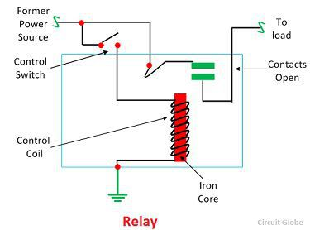](https://circuitglobe.com/wp-content/uploads/2017/01/relay-image.jpg)

CONSTRUCTION:

The relay operates both electrically and mechanically. It consists electromagnetic and sets of contacts which perform the operation of the switching. The construction of relay is mainly classified into four groups. They are the contacts, bearings, electromechanical design, terminations and housing.

**Contacts –** The contacts are the most important part of the relay that affects the reliability. The good contact gives limited contact resistance and reduced contact wear. The selection of the contact material depends upon the several factors like nature of the current to be interrupted, the magnitude of the current to be interrupted, frequency and voltage of operation.

**Bearing –** The bearing may be a single ball, multi-ball, pivot-ball and jewel bearing. The single ball bearing is used for high sensitivity and low friction. The multi-ball bearing provides low friction and greater resistance to shock.

**Electromechanical design –** The electromechanical design includes the design of the magnetic circuit and the mechanical attachment of core, yoke and armature. The reluctance of the magnetic path is kept minimum for making the circuit more efficient. The electromagnet is made up of soft iron, and the coil current is usually restricted to 5A and the coil voltage to 220V.

**Terminations and Housing –** The assembly of an armature with the magnet and the base is made with the help of spring. The spring is insulated from the armature by moulded blocks which provide dimensional stability. The fixed contacts are usually spot welded on the terminal link.

**CHAPTER 7**

**SMART PASS BOX CONTROLLER**

INTRODUCTION:

Pass Box is used for material transfer from one room to another room. It consists of a rectangular box with two doors. The two doors are interlocked such that both doors cannot be open at the same time, to prevent pressure losses and cross contamination.

Pass Box is equipped with the UV lamp which is used for sterilization (Sterilization is a term referring to any process that eliminates or kills all forms of microbial life, including transmissible agents present on a surface, contained in a fluid or in a compound such as biological culture media).

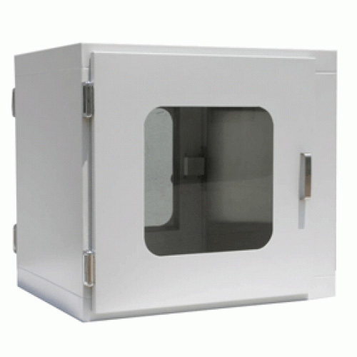

Pass box is provided with two interlocked doors i.e., when one door is open the other door remains closed, in this way it prevents the direct contact between the connected areas. A Reliable Interlock System prevents the two opposite doors of the Pass Box from being opened at the same time, to maintain the stability of the clean room atmosphere

TYPES OF PASS BOX:

**STATIC PASS BOX:**

Static Pass Boxes are simple boxes mounted between two areas and also known as “Passive Boxes”. The area having higher cleanliness level shall have the higher pressure that helps to prevent the contamination in the sterile area.

Ultraviolet Light are also installed in the Pass Boxes to remove the contamination that may enter during the transfer of the material. It should be replaced after 1000 thousand burning hours.

They are designed to work with minimal personnel movement while dynamic pass box are used to pass through materials from an uncontrolled environment to a controlled environment. A static pass box should never be used to transfer the material between a clean room and a non clean room.

Pass boxes should be cleaned with disinfectants at regular intervals. The efficiency of the pass boxes should be verified by validation. Validation should be done by exposing the known population of bacterial culture.

**DYNAMIC PASSBOX:**

Dynamic pass box works like an airlock or Laminar Air Flow Unit. Clean air enters in the pass box and prevents the entrance of the contamination. Dynamic pass boxes may be castcade, sink or bubble type similar to the airlocks in pharmaceuticals.

A Dynamic Pass Box is a cubical box which has got the inter-locked doors on both sides. This protects the controlled environment from being polluted during the transfer of material.

Dynamic Pass Boxes are used for the transfer of material from one area to another in isolation by means of mechanical/electromagnetic door interlocking process that ensures opening of only one door at a time. This process helps in avoiding cross contamination between two areas.

Pre-filters are attached to the Pass Box which are made from fiber glass media to achieve high filtration efficiency and filtration accuracy of up to 5.0 microns.

These are used to block major particles from air within hatch being sucked by blowers & then passing it through discharge filters thus enhancing life of discharge filters.

UNIQUENESS OF THE INNOVATION:

The Automatic Door configuration includes one Automatic Door on the "clean" side and the other door on the "dirty" side. Automatic doors and ultrasonic sensors can be installed on both sides of the pass box on a custom basis.

The pass box consists of interlocking doors mechanism. The electromagnet gets activated through relay if no motion was detected by the ultrasonic sensor. If the sensor detects any motion within a particular range it deactivates the electromagnet and the door opens, then the impure material will be placed in the box. The UV light eliminates the impurities present and the material gets collected from the other door. If both ultrasonic sensors detects the motion simultaneously within the given range then the pass box remains in the initial state i.e., the two doors remain closed.

CONSTRUCTION:

Here, we use microcontroller which operates all the devices present in the circuit. All devices are connected to the microcontroller. The UV light is placed inside the box to remove the impurities if present. The electromagnets are fixed at the two doors. The electromagnet helps the door to remain in the closed position during sterilization process. The ultrasonic sensors are installed at the two doors of the Pass Box. Whenever the ultrasonic sensor detects the motion it releases the door from the electromagnet using relay. The relay converts the minimum input voltage to the maximum output voltage. Here we use the 4-channel relay. The output of the ultrasonic sensor is given to the Arduino Mega Board (The sensor1 is connected to the Arduino digital pin 2(echo pin), 3(trig pin) and the sensor2 is connected to the Arduino Digital pin 5(echo pin), 4(trig pin)). We use only three relays in the given 4-channel module. The relays are connected to the Arduino Mega board at the digital Pin 8(relay1), 9(relay2),10(relay3). The relays 1, 2 are connected to the two electromagnets and relay3 is connected to the UV light.

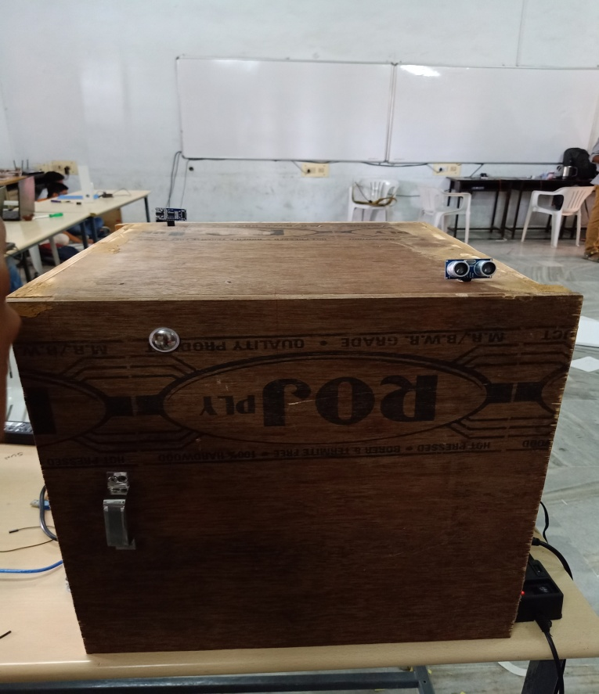 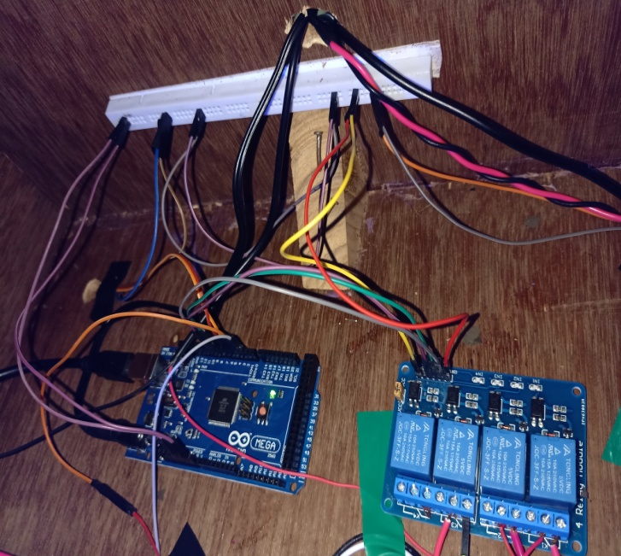

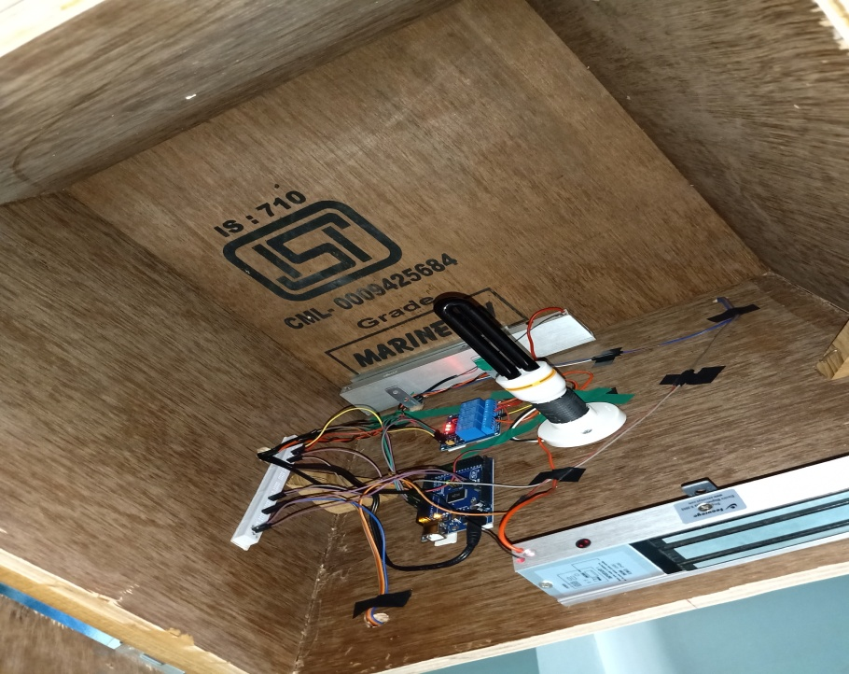

WORKING:

Whenever the ultrasonic sensor detects any motion in front of it then the sensor send its output as 1 to the microcontroller. Then microcontroller sends an input signal to the relay. The relay receives this signal. The relay converts the minimum input voltage to the maximum output voltage and gives supply to the two electromagnets and the UV light. Based on the output given by the Microcontroller one of the door will be opened automatically and we can place the material inside the box and close the door for sterilization process to take place, this process continues for 1 minute. After the time lapse if the other ultrasonic sensor detects the motion on it’s side the electromagnet gets demagnetized and the door gets opened automatically and we will collect the pure material.

BLOCK DIAGRAM:

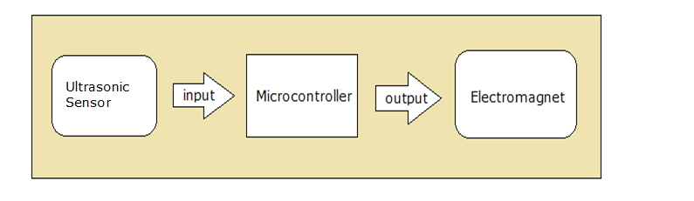

CONCEPT AND OBJECTIVES:

In the process of material transfer from unclassified area to classified area pass boxes are used. Pass box is rectangular box with two doors. The two doors are interlocked such a way that two doors cannot be open at the same time, due to which pressure losses and bacterial contamination doesn’t take place throughout the material transferring process. The Automatic door operator eliminates touch contamination. Hands-free operation is especially well suited for pharmaceutical and medical applications as it negates the need for hand cleaning or re-gloving after using Pass box. Whenever the motion sensor activated the pass box turns on else remains off to reduce the power consumption. The prevention of simultaneous access of doors is been achieved by our Pass Box controller by ensuring that when one door for a Pass box is open then other door is closed.

PROJECT CODE:

#define trigPin1 3 // Door 2 Sensor (RIGHT)  
#define echoPin1 2  // Door 2 Sensor (RIGHT)  
#define trigPin2 4 // Door 1 Sensor (LEFT)  
#define echoPin2 5 // Door 1 Sensor (LEFT)  
int Door1=8;  
int Door2=9;  
int UV=10;

long duration, distance, RightSensor,LeftSensor;  
  
void setup()  
{  
Serial.begin (9600);  
pinMode(trigPin1, OUTPUT);  
pinMode(echoPin1, INPUT);  
pinMode(trigPin2, OUTPUT);  
pinMode(echoPin2, INPUT);  
pinMode(Door1, OUTPUT);  
pinMode(Door2, OUTPUT);  
pinMode(UV, OUTPUT);  
}  
  
void loop()   
{  
SonarSensor(trigPin1, echoPin1);  
RightSensor = distance;  
SonarSensor(trigPin2, echoPin2);  
LeftSensor = distance;  
  
Serial.print(LeftSensor);  
Serial.print(" - ");  
  
Serial.println(RightSensor);  
  
digitalWrite(Door1,HIGH);  
digitalWrite(Door2,HIGH);  
digitalWrite(UV,HIGH);  
  
if(((LeftSensor<10)&&(RightSensor>10))||((LeftSensor>10)&&(RightSensor<10)))  
{  
if (LeftSensor<10)  
{  
  digitalWrite(Door1,LOW); //Door1 open  
  digitalWrite(UV,LOW);   // UV Off  
  delay(2000);  
  digitalWrite(Door1,HIGH);  
  digitalWrite(Door2,HIGH);  
  digitalWrite(UV,HIGH);  
  delay(10000);  
}  
  
if(RightSensor<10)  
{  
    
  digitalWrite(Door2,LOW);  
  digitalWrite(UV,LOW);  
  delay(2000);             //4time door will be opened for: 2 sec  
  digitalWrite(Door1,HIGH);  
  digitalWrite(Door2,HIGH);  
  digitalWrite(UV,HIGH);  
  delay(10000);             //time uv light on for: 10 sec  
}  
}  
else  
{  
  digitalWrite(Door1,HIGH);  
  digitalWrite(Door2,HIGH);  
  digitalWrite(UV,HIGH);  
}  
}  
  
void SonarSensor(int trigPin,int echoPin)  
{  
digitalWrite(trigPin, LOW);  
delayMicroseconds(2);  
digitalWrite(trigPin, HIGH);  
delayMicroseconds(10);  
digitalWrite(trigPin, LOW);  
duration = pulseIn(echoPin, HIGH);  
distance = (duration/2) / 29.1;  
}

APPLICATIONS:

Space applications

Electronic industry

Chemical industry

Diagnostics labs

Pharmaceutical industry

Bio technology

Health care centers